Title: Write 64-bit ALP to accept number and display it on screen.

Code:

%macro scall 4

mov rax,%1

mov rdi,%2

mov rsi,%3

mov rdx,%4

syscall

%endmacro

section .data

m1 db "Enter 64 bit no=",10d,13d

l1 equ $-m1

m2 db "The 64 bit no is =",10d,13d

l2 equ $-m2

section .bss

num resq 1

section .text

global _start

_start:

scall 1,1,m1,l1

scall 0,0,num,17

scall 1,1,m2,l2

scall 1,1,num,17

mov rax,60

mov rdi,0

syscall

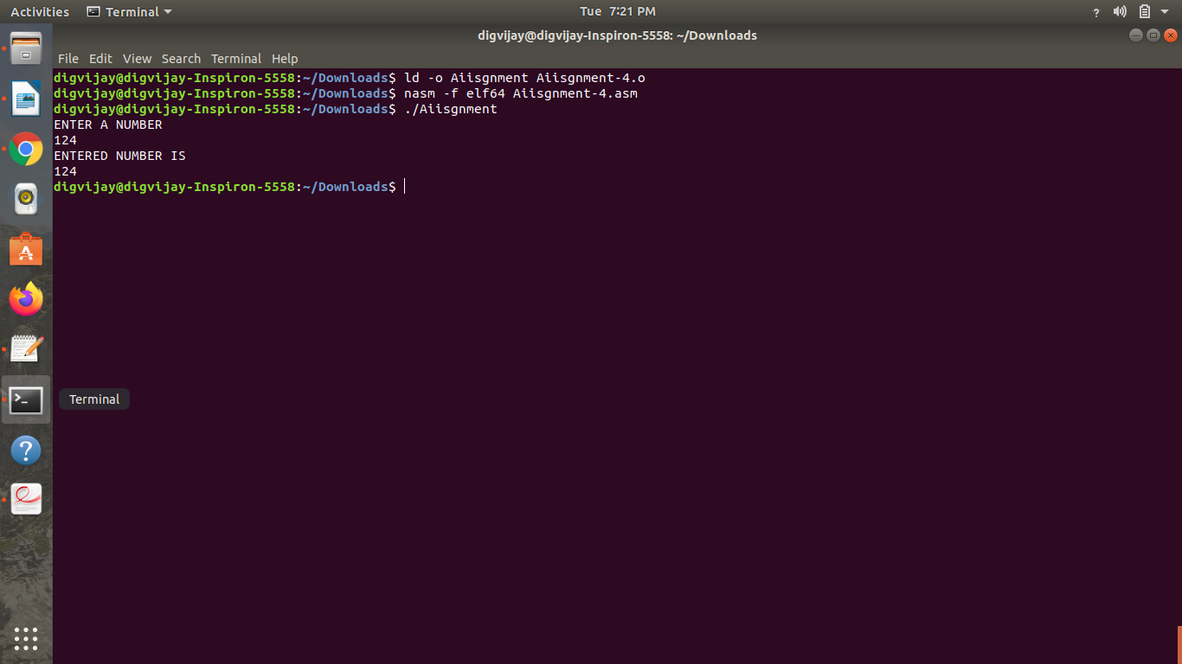Output: